Product Review: Team Losi Night Crawler BND  Words: Chris Long  Photos: TBD  Links:  http://teamlosi.com  http://maxamps.com | 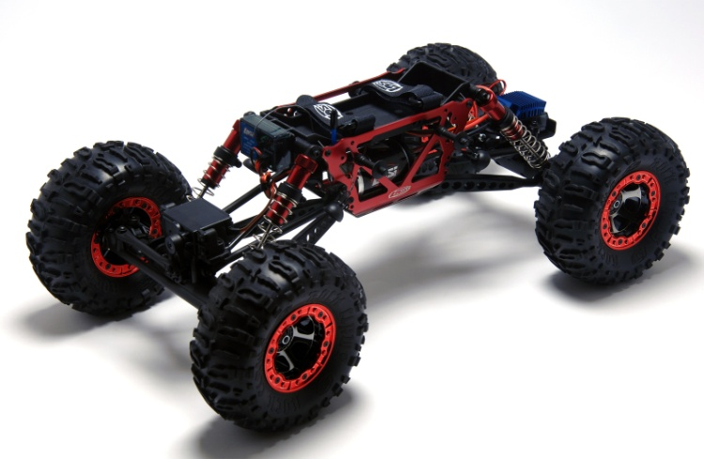

Introduction
With the long winter nights upon us Losi has struck back with a Bind-N-Drive version of the Night Crawler. Just bring your existing Spektrum 2.4Ghz DSM radio and a battery; this kit includes everything else to get you onto the rocks and driving well into the night under the power of bright LEDs.
Performance
The first thing you notice when getting the crawler out of the box is the great looking competition legal Grappler Pro body and the considerable amount of red anodized parts from the bleadlock rings to the shocks and main chassis plates. All that was left was to mount the battery in the adjustable battery tray in the forward position and bind the receiver to my DX3R.
On the rocks the worm axles of the Losi crawler work well – The complete off power axle lock of the worm gears takes a while to get used but creates a slow predictable driving experience. The amount of reduction in the transmission combined with the high torque 55T motor on 2S LiPo does sacrifice some speed but provides a very smooth low speed drive and lots of torque. You could try gearing slightly higher but you’d have to pay close attention to the motor temperatures.
In stock format the car didn’t climb as well as I knew it could as the wheels were un-weighted – As a first start adding 6Oz of lead to lead front wheel and a 2Oz in the rear helped settle the car down and it climbed like a goat. With the real beadlocks this process is pretty straight forward if a little fiddly with the small screws. The Losi Claws did a good job of gripping a variety of different rocks and playing around in the yard but for “competition” use I’d swap out to the new Losi Boss or Comp Claws.
The stock metal gear steering servo worked well in turning the truck on flat rocks or when rolling but when a wheel was stuck in a rock or you needed to wiggle the steering to settle the car a few extra Oz of torque would really help. Upgrading to something like the JR9100T would really help to liven up the steering response.
The 4-link suspension and aluminum shocks were very smooth and worked climbing and in off camber situations – It was very easy to use the spring adjusters to quickly make changes to the preload and tune the shocks.
At night the LED lights came into play and I was able to tweak the lights to provide plenty of forward illumination and continue well into the night. With the LEDS being tucked inside the body there was never any risk of them getting knocked or damaged. A nice bonus feature.
The last word
The Losi BND Night Crawler is ready out of the box to tear up the rocks anytime day or night. The combination of the night crawling, simple electronics and worm gear axles makes driving the car straightforward and fun if you are new to crawling or opens up new challenges/opportunities to a veteran driver. In addition the Night Crawler provides an easy route to upgrade parts by taking upgrades or parts from the competition winning Losi Comp Crawler.

Need to Know
- The package includes everything you need to be on the rocks in seconds – Just plug in a Losi LiPo battery and bind the included Spektrum receiver to your radio and hit the rocks. With some minor setup changes (adding weight) the car is ready to compete out of the box in the Sportsman class at your local RC Crawler club.
- The BND Night Crawler is identical in specification to the regular Night Crawler except for the lack of the radio transmitter and the change to all red anodized parts.
- The Losi Night Crawler positions the battery above the transmission which increases the center of gravity slightly higher than its competition cousin. This battery tray though can be configured to take all different kinds of battery from a regular full size NiMH / LiPo stick pack or any of the.2-inch Losi LiPo crawler battery packs.
- Continuing the theme the BND Night Crawler comes prewired with front and rear LEDs that can be positioned to light up all four corners of the car and provides just enough light to allow you to stay crawling well into the evening.
- The vehicle is intended for anyone who already has a Spektrum or Losi 2.4Ghz transmitter - The included 3 channel Losi 2.4Ghz RX should bind easily to any car Losi or Spektrum 2.4Ghz radio from the 2.0 to the 3R.
- The Night Crawler uses plastic lower links and front tie rod however they seem to be very rigid and didn’t flex significantly in testing – This don’t look to be an area for immediate upgrade.
- The initial problems with the early Losi 1/10th crawlers breaking CVDs looks to be a thing of the past. The latest iteration of the CVD’s are very strong and together with the zero Ackerman you can now make every use of the 45 degrees of steering in confidence.

Design Analysis
- The Night Crawler uses the same twin vertical plate chassis (anodized red for the BND) and 4-link design as the Losi Competition Crawler. This proven setup minimizes any rear axle swing and provides more precise handling whilst the TVP keeps the transmission and motor are mounted as low as possible to create a low center of gravity.
- The simple Losi 12T ESC has no need of complicated features – The simple 1 touch setup includes the option to toggle between standard and crawler specific drive modes and to enable the LiPo cutoff.
- The LCC uses worm gears in the front and rear axles. Whilst worm gears have much higher drag (more strain on your electronics) they have several advantages for rock crawlers; they only rotate under power and hence provide massive amounts of drag brake off power; they don’t suffer from torque twist as a regular differential and the small gear assembly provides extra ground clearance under the axle housing. The Losi worm axles have proven to be very reliable with the latest CVD design.
- Losi designed a simple direct-drive transmission for the Night Crawler which is mounted low down in the chassis – The compact transmission is provides an ultra-low gear ratio to complement the worm axles and metal outputs for strength. The Night Crawler falls into the Sportman category and does not have “dig” (ability to lock rear or front wheels) - To add the dig feature you could simply replace the transmission with one from the LCC.
- The 4" shocks are of a three piece design and come in bright anodized red aluminum. Rather than being threaded like the LCC the Night Crawler uses adjustable collars which clamp onto the shock body. These worked well showed no signs of working loose during testing.
- The wheels are of a 3-piece beadlock design with red anodized rings to continue the theme – The beadlocks make it easy to change tires or add weight as required. The package doesn’t come with weights but it’s worth adding 6Oz to each front wheel as a start and then tune from there. The wheels come pre-mounted with 2.2 Losi Rock claw tires which work well but are a little dated – Upgrading to the newer Losi Boss Claws would be a worthy upgrade.

Pros and Cons
+Worm gear axles provide instant and v strong drag brakes
+Bullet proof drive train requires no upgrades
+ LiPo compatible ESC
+45deg of steering
- Rock claw tires are a little dated – Comp Claws or Boss Claws would be a worthy upgrade
- Servo could do with a few more Oz

At a Glance
Who makes it | Team Losi
Who’s it for | Sportsman / Novice Crawlers
How fast | A crawl
How much | MSRP: $499.99  Available for*: $339.99
Build type | RTR – Bind and drive
Vehicle Type | 2.2 Crawler
The bottom Line | A ready to rock crawler perfect for anyone with a Spektrum radio and looking to get into RC Rock Crawling in either the Sportsman class or just having fun on the rocks.

Items Needed / Used
- Maxamps 7.4V LiPo Battery Pack
- Spektrum 2.4Ghz DSM Radio (DX3R Used)
- Lithium Grease
Specs and Tuning Options
Dimensions | Length:17.5 in (444.5mm)  Width:9.875 in (250.8mm)  Wheelbase:12.3 in (312.4mm)  Weight:4.18 lb (1.9kg)
Suspension | 4-link suspension with 4” aluminum shocks with adjustable collars
Drive train | 55T/540 Motor with Losi LiPo compatable crawler ESC  Locked worm gear axles with locked transmission
Maintenance and tuning tips | Worm gears are great for drag brakes but are inefficient. Examine the worm gear axles regularly and unsure that they have plenty of high temperature grease to avoid extra drivetrain drag.

