RCDriver Magazine
Issue: 0711
Driven Review: Team Associated TC6
Subhead: High End Road Racer
VEHICLE TYPE: 1/10 4WD on-road touring car
WORDS: Dan Gomez
PHOTOS: Walter Sidas
Pages: 4

The TC6 is the latest weapon in the Team Associated arsenal for the 1/10-scale electric touring car class. This new model represents the advancements made over years of racing previous generations of cars. It has kept what is known to work and refined other areas to improve its performance while using all the latest technology in electronics. The Team Associated TC6 has a lot of hype to live up to. We get to take a look at the TC6 and put it through its paces to see if it meets our high expectations.

AT A GLANCE
WHO MAKES IT: Team Associated
WHO IT’S FOR: Intermediate to Advanced Drivers
HOW FAST: 35.4mph [filled in by RCD staff]
HOW MUCH:400
BUILD TYPE: Kit

PROS & CONS
+ Narrow chassis
+ Ultra smooth threaded shocks work flawlessly
+ Comes with a ball differential for silky smooth performance
+ High quality parts used throughout
+ Great fit and finish
+ Chassis is LiPo ready
- CVD’s had some bind when built. They had to be worked in to perform as smoothly as possible.

Authors Opinion: The TC6 is the newest in a long line of top level touring cars. Associated packed the car with performance and has once again refined the car to make it a better performer.

Star rating (1-5) = 4

FACTS [author please give opinionated information about design, materials and so on of important features of the vehicle]
-The TC6 chassis has been optimized for LiPo batteries and brushless motors. The motor has been moved 13mm toward the center of the chassis which helps balance the car left to right when using lighter LiPo batteries.

-The steering system has also been completely revamped to provide more consistent handling through the travel. The new geometry gives the car a more linear steering feel and has a lot of tuning options to make the car handle to your liking.

-The chassis consists of two carbon fiber plates (upper and lower) held together by four symmetrical aluminum bulkheads. This gives the TC6 a sturdy platform to build on, while the symmetrical bulkheads enable you to carry fewer spare parts in your pit bag. This also helps Team Associated balance the car as all four corners are the same.

-While the plastic suspension components remain unchanged, Team Associated has updated to the VCS3 shocks. They are threaded and have bottom loaded cartridges which allow for more up travel while remaining dimensionally the same.

-The suspension mounts have been redesigned with easy access to the mounting screws. This allows you to remove the suspension components much easier than in the past. It also allows you to change suspension mounting positions quickly and easily to alter roll center, anti -squat, anti-dive and track width.

ITEMS USED
- LRP SXX-TC ESC w/ V12 5.5 motor- LRP80795
- Team Associated XP Digital 1015 Servo- ASC29167
- Reedy 5200mAh 7.4V LiPo battery- 709
- Futaba 4PKS radio- FUTK4901
- Kustom RC Graphics Paint

ON THE TRACK [author- for a performance vehicle, follow the template below. For more of a basher vehicle, feel free to create a story about the fun and excitement you had. Please give an Overall Performance Rating: Poor Fair Good Very Good Excellent]
(Bold Performance Rating)
STEERING Understeer Neutral Oversteer
I love the new steering on the TC6. The Ackerman has been altered and the new steering bell crank is highly adjustable to offer very consistent linear steering. The car has much better overall steering than its predecessor and is much easier to drive.

ACCELERATION Poor Fair Good Very Good Excellent
The TC6 has a near perfect pulley ratio of 2:1. This seems to be the best combination of pulley sizes and offers exceptional durability combined with low friction, allowing this car to rocket from corner to corner. Additionally, the TC6 is very lightweight so the car gets going quickly when you pull the trigger.

BRAKING Poor Fair Good Very Good Excellent
Braking is very controlled and very quick. If you grab too much brake all at once, the car tends to push a bit. This is mostly because of the front slipper spool. However, even with the slight push it is easy to control in panic break situations.

SUSPENSION Poor Fair Good Very Good Excellent
The suspension on this car is excellent and the new suspension mounts make access much easier than in the past. It is very adjustable so you can dial the car into your track conditions quickly. Overall, the balance is perfect and both the front suspension and the rear work in perfect harmony.

DURABILITY Poor Fair Good Very Good Excellent
I have been racing the TC6 for nearly a full season of indoor carpet racing and have yet to break one part. The drivetrain has been silky smooth and I’ve done nothing more than routine maintenance. I would say that the car is definitely up to the rigors of competitive racing.

THE LAST WORD
The Team Associated TC6 not only meets our expectations but blows them away in every way possible. The car is light and nimble and slices around the track with precision handling. The advancements made to the car not only make it perform on the track, but they also make the car easier to adjust and work on. The TC6 is sure to be on top of the podium at races all around the world.

LINKS
Team Associated, teamassociated.com, rc10.com, (949) 544-7500
Parma/PSE, parmapse.com, (440) 237-8650
LRP, distributed by Team Associated, teamassociated.com, (714) 850-9342
Reedy, a division of Team Associated, teamassociated.com, (714) 850-9342

CAPTIONS
SCR chassis 1
The long narrow chassis keeps all the components mounted as close to the center line as possible to achieve a near perfect balance.

SCR chassis 2
For our SCR we used the LRP SXX Speed control and X-12 vector motor, As well as a good Savox steering servo.

SCR bottom
The long channel in the center is where the battery sits to keep the center of gravity as pow as possible. The sides are narrow and raised up to keep the chassis from rubbing the ground while coenering.

SCR front sus
Long travel front suspension along with the velvet coated shocks make for an ultra plush ride and keep the tires in contact with the ground under all conditions.

SCR rear sus
Inside the rear gearbox you will find a ball differential which transfers the power smoothly to the rear wheels through the included cvd axels.

SCR Wheel and tire
The kyosho SCR uses standard offset short course wheels with 12mm hex adaptors for mounting. We used these AKA wishbones tires in super soft compound to make the truck hook up to the track.

BONUS WEB CONTENT

TEAM ASSOCIATED TC6

AT A GLANCE
WHO MAKES IT: Team Associated
WHO IT’S FOR: Intermediate to Advanced Drivers
HOW MUCH: $400
PART NUMBER: 19er54
VEHICLE TYPE: 1/10 4WD electric on-road touring car kit
COMPANY LINK: rc10.com

COOL FACTS [author here you can discuss the vehicles basic features]
-The Team Associated TC6 is a kit. It comes in a box, unassembled with a decent set of instructions and you will need about 5 hours to assemble it. The car goes together nicely and needed very little hand fitting.

-The TC6 is a pro level kit; it does not include electronics, wheels, tires, and a body. All racers like to pick out these items to best suit the location that they will be running on. Like most cars in this class these options are left up to the owner to pick which equipment he uses.

-High end materials have been user throughout the car. Carbon fiber, Aluminum, and titanium as well as high quality plastic are the main components for the car. These high grade materials give you a car that is as light as possible and ensure that the car can perform at the highest level.

-Most of the suspension components are carried over from the TC5 touring car. The arms, c-hubs, steering hubs are same as the previous model which makes spare parts easy to find.

-This car was designed around the popular rubber tire sedan racing class. The chassis is made of a moderate thickness carbon fiber that allows it to be rigid, while still offering good flex to increase grip levels. The car also comes with a ball differential in the rear while a slipper spool is found up front. This is the ideal combination for rubber tire racing.

PERFORMANCE TEASER [author please create a brief exciting performance synopsis]
Steering- The car has much better overall steering than its predecessor and is much easier to drive.

TOOLS & ACCESSORIES INCLUDED
+ Metric Hex Wrenches
+ 4-way Wrench

ITEMS NEEDED TO RUN THIS CAR
1/10 scale brushless speed controller and motor
Steering servo
7.4v Lipo racing pack
Radio transmitter and receiver
Touring car body
Wheels and tires

SPECS & TUNING OPTIONS
Team Associated TC6

DIMENSIONS
Length: 15” (381mm)
Width: 7.5” (190mm)
Wheelbase: 10.05”-10.3” (255.5mm- 261.5mm_
Weight: varies with components used

Body, wheels and tires
Body:
Wheels:
Wheel adapter type:
Tires:

Suspension
Type:
Shock positions: 5-tower, 2-arm
Camber: Adjustable turnbuckle
Roll: various positions and ball stud mounting height shock towers
Wheelbase: spacers included
Ride height: threaded shocks
Misc: Anti squat, Anti dive, Track width

Steering
Type:
Toe: Adjustable turnbuckles

Chassis
Type:
Material:
Thickness:
Misc: Flex of chassis can be altered by removing screws

Drivetrain
Type:
Transmission:
Differential:
Clutch Type:
Gear ratio: optional pinion gears
Bearings:
Misc- Can be built with a front diff or a front slipper spool

MAINTENANCE AND TUNING TIPS
- You should always check ride height and tweak on the car before a day at the track. It will help keep the car balanced and handling at it best.
- I rebuild the shocks with fresh oils every couple of outings to keep the car at its optimal performance level. Also pay attention to the differential as well. After a few battery packs, check and reset the diff so it does not slip.
- After every couple of battery packs you should inspect the car for loose screws or worn parts. This is a good habit with any car.
- When trying to dial in the car to your driving style make sure to make one adjustment at a time. Making multiple adjustments at the same time is a good way to get yourself “dialed out”.

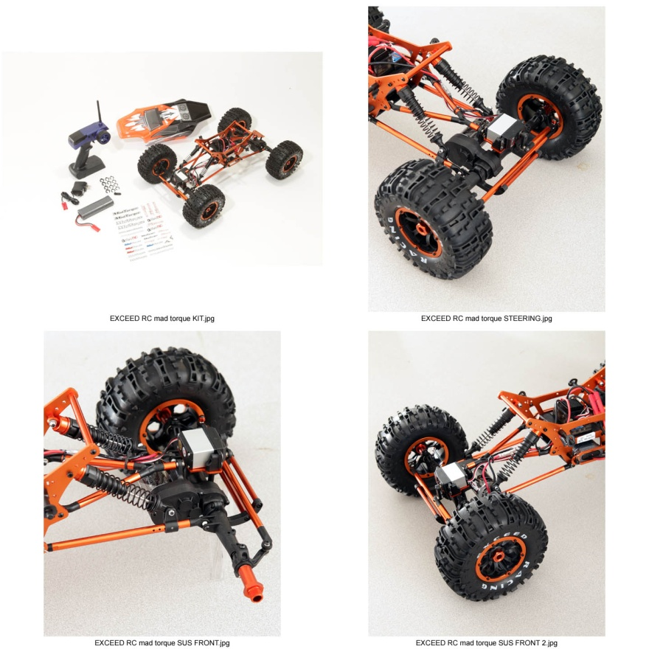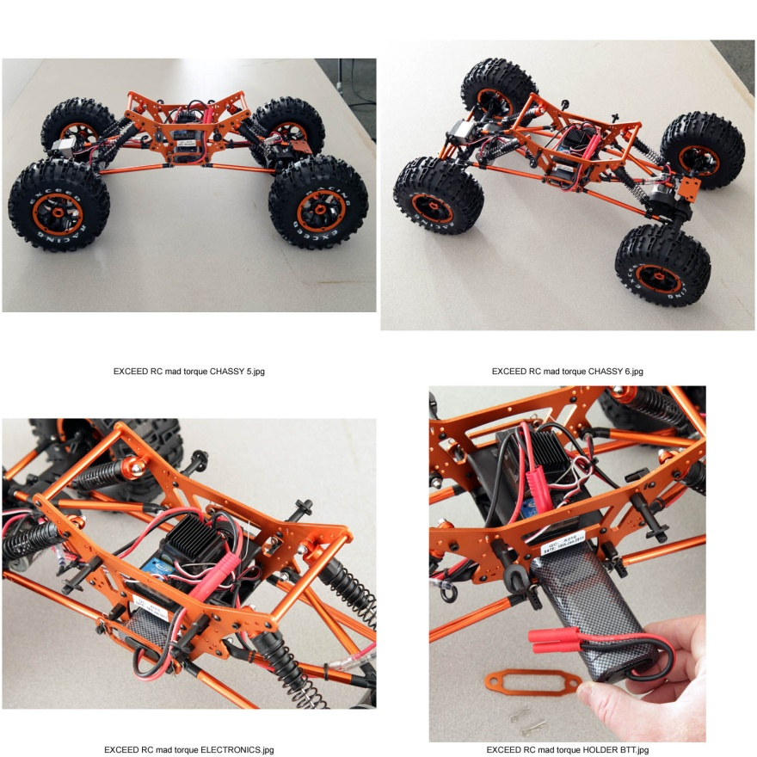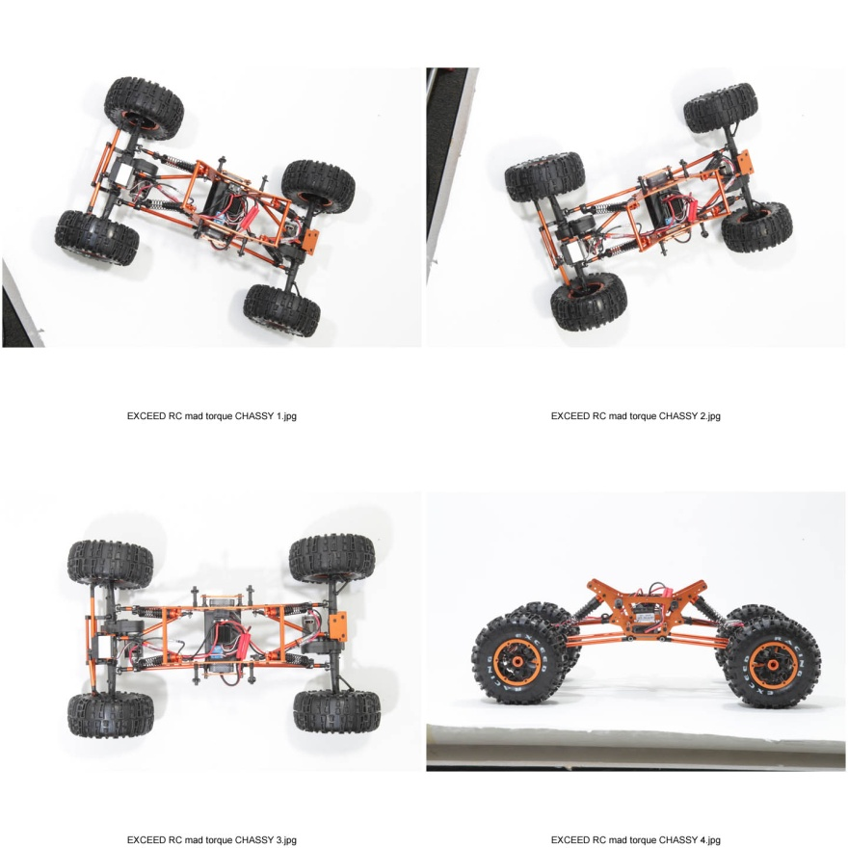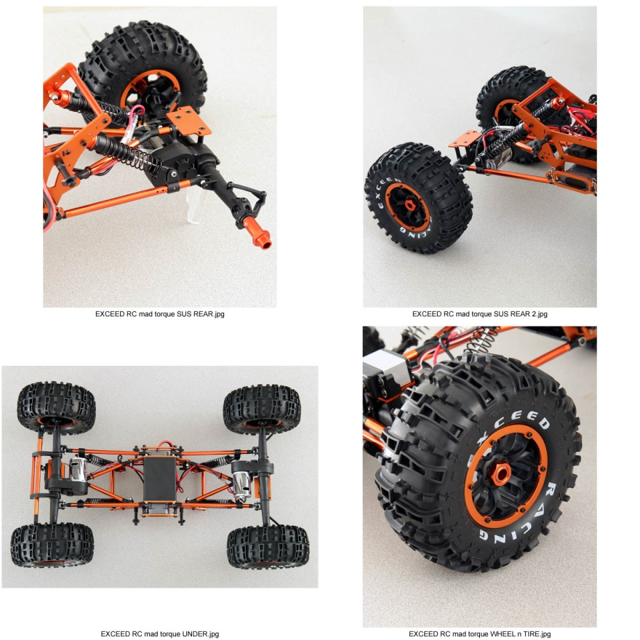
So, to start off, I got mine through NitroRCX.com for $159 (an ARTR version without a radio is $139) and since they ship from California, I got it very quick, about 3 or 4 days. I've always had good luck with the Nitro Models family of web stores (hobbypartz, xheli, nitrorcx, etc) so I've come to expect that from them.
I was going to take some pics of the unboxing, but really, there's nothing exciting about that. There are a ton of detailed pictures of the vehicle on NitroRCX's website, so I won't repeat those pics.
The vehicle comes fully assembled and ready to run, including:
2.4ghz Radio
3000mah 6 cell 7.2v NiMh battery and charger (battery has bullet plugs installed)
User manual
Decal Sheet
Shock pre-load clips
Extra servo horn
I am a little surprised that it didn't come with a wheel wrench. They can be found cheap and some people have 17mm sockets they can use if they need to (more about this in the wheels/tires section.)
First thing I did was get the battery on the charger and start flipping through the user manual.
Battery/Charger
The battery and charger are the basic 'plug-it-in-the-wall-and-wait-overnight' type of NiMh chargers. The connectors are the 4mm bullet connectors you find on a lot of batteries that come from overseas. I ran these connectors for the first run to see if I would notice a difference. They seemed fine, but are bulky and difficult to disconnect, so I ended up changing to deans plugs.
User Manual
I was initially impressed with the user manual. It's actually a step by step build manual. Other previous Exceed RTR's that I've seen usually have a general 'manual' with only exploded views that make it a little difficult to see what is what. I appreciate that it actually shows how to put it together and in what order.
The diagrams are very clear and there's hardly any engrish (only thing that stuck out was 'disks fixing tire' for the beadlock rings) and there's a parts list (with diagrams) and option parts list as well.
There was also a seperate sheet for the radio and the esc, written in plain english, as well as some extra decals in case you wanted to use them.
While I was waiting for the battery to finish charger, I decided to take a look over the vehicle and make a few notes.
Initial Impression, Overall design:
Body
I actually like the body for this, it is sitting pretty low on the chassis, especially compared to other Exceed crawlers I've seen, and doesn't really need any trimming to clear the tires or shocks, etc.
It looks to be very similar to the Pro-line Crowd Pleazer bodies.
I do actually like the paint scheme on the body though. (I even had a fellow crawler ask me who painted it for me.)
One gripe is that the body mounts on the side, but that is pretty minor, and more of my personal preference.
Tires/Foams
I was initially impressed with the compound of the tires; they seemed sticky enough, probably similar to Pro-Line's M2 compound and the tread pattern is crawler specific. A lot of these type of crawlers use knock-off treads, but I can't see any similarities with a major brand. To me that seems like they are actually doing their own engineering and designing. The tires are about 6.25" tall, and are short compared to most super class crawlers.
I am very disappointed in the foams though. They are a flat foam curved around the rim, with a glue seam, and they are too stiff and too short. The glue seam isn't bad necessarily, but the glue they used is a little stiff compared to a normal 3M spray glue. With the foam being too short, the tire has room for slop, and I definitely recommend getting different foams for the tires.
Wheels
The wheels are true beadlock with anodized aluminum rings, 2.8" diameter x 2.8" wide with 17mm hexes. This makes them to small to be used in any USRCCA sanctioned comp where the minimum is 3.2" diameter. If your local competitions do not mind, you may be able to just use these wheels. They do seem to hold a bead very well, but being plastic, I am afraid the screw threads will strip similar to most plastic beadlocks. If this happens, an easy fix is to get 2-56 hardware which is slightly larger than the M2 screws that it comes with.
Suspension/Linkage
The suspension includes plastic bodied oil filled shocks, aluminum 3 link design linkage, with the shocks mounted to the lower links. The shocks seem smooth, and the spring rate seems appropriate for the size of vehicle. The links and rod ends seem small though, using M3 set screws and 7mm aluminum links. I will upgrade those when I get to that stage of the review.
One thing I don't like is that the location where the shocks mount to the links causes a little bit of slop, and the motor-side shock does interfere with where the wire connects to the motor. There's a simple fix for the interference below, but the 'slop' is inherant in mounting the shock to the links. Also, the top of the shocks mount on the inside of the chassis, in what I think is an awkward position.
The lower links are not triangulated, probably to more easily clear the motor, but do allow a little bit of axle swing, and thus instability. The upper links are a 3-link 'Y' design with a little more slop on the axle side of the linkage. When I change out the links, I will change the upper links to a 4-link set up to reduce the slop in this area.
To be fair, most RTRs come with a link set-up like this.
Chassis
The chassis is a pretty basic TVP design with a little room for adjustment, made from more anodized aluminum. The battery is designed to be mounted on the skid plate, nice and low, which is something I didn't expect from a crawler this inexpensive, with the electronics mounted on a mid-plate (which is just another skid plate mounted above the battery.)
I've seen a few of the other guys chop the chassis for their builds, but I would like to see a longer chassis to get the shocks to mount on the axle rather than the links. This can be done by either making your own chassis or buying one from the vendors on this forum. I plan to make a 'bodiless' style chassis for this in the near future.
Axles
These are motor-on-axle design, made from plastic, in a 3 piece design. I'm not sure of the plastic compound, but they do seem to be a much better plastic that what you would expect at this price. More testing will show whether they can stand up to competition abuse. They are 3 piece design meaning there's a center gear box and a left and a right tube, with the c-hubs built in to the tubes. This is a little strange, since if the c breaks, you have to replace the entire tube (which is only a few bucks.)
The knuckles are also plastic and seem to be based on the AX10 knuckle, and other users have confirmed that AX10 knuckles will swap directly on with no modifications. This means you can find inexpensive knuckles or "zero ackerman" or "high clearance" knuckles for this crawler.
I will go into more detail about the internals a little later in the review, but from what I have seen the gears are all hardened steel, and seem to hold up to some good abuse.
Electronics
I will go into more detail on the electronics after I post info on the first run.
The motors are a closed end-bell 70T 540 type, powered by a dual motor crawler ESC which is capable of up to 7 cell Nickel batteries. You can run 2S LiPo on this ESC, but you will need some sort of low voltage cut-off to prevent over-draining the battery. There is no programmability or dig function with this ESC, but that is expected with an RTR esc.
The included servo is around 200 oz-in and is mounted to a plate on the axle very similar to the way the AX10 does it. (The servo plate looks very similar) although the servo is a little higher than I would prefer, and definitely under-powered for a vehicle this size, especially if you want to install bigger tires. The servo linkage is similar to the suspension linkage, and seems to hold up just fine.
The crawler does include a rear plate, and the rear axle has knuckles installed to make it easy to convert to rear steer. All you need is the "Truck Conversion Kit" in your favorite color, a y-harness, and a second servo. (If you want to switch between 4WS, Crab walk and Front only steer, you will need at least a 3 ch radio with that functionality.)
Radio System
More and more RTR vehicles are including 2.4GHz radio systems, and this is no exception. The radio seems to be based on the Fly Sky FS-GT2 "platform" with the receiver resembling the RC4WD XR4 receivers. I suspect that the radio is compatible with most of the Version B Fly Sky receivers, as well as the RC4WD receivers as well. I have not confirmed this though, it is just a suspicion. The receiver comes already bound to the radio.
It is only a 2 ch transmitter, but strangely has a 4 ch receiver. The transmitter is comfortable and lightweight, using only 4 AA batteries. There are trim knobs for the throttle and steering center point as well as dual rate knobs and reverse switches. The transmitter also has a charging port on the back of it, but does not include a charger.
The wheel has good travel and spring, but does bounce a little if you let go at full lock (most inexpensive radios do this though) and the throttle trigger feels nice with good travel as well. I actually really like this design, and think it is one of the more comfortable controllers I have ever used.
Miscellaneous
The vehicle comes with a bumper which can get in the way if you approach a rock head on, but is very easy to remove. I assume they installed it with the intention of protecting the servo linkage, which it does, but is in the way the rest of the time.
The vehicle does use all hex hardware, which is definitely appreciated, and makes it easier to prevent stripping screw heads. Also, it has become expected, but does use bearings throughout.
Parts can be found through hobbypartz or nitrorcx, and again, since they are coming from California, you shouldn't have to wait too long for them. Honestly, most of the replacement parts for any of my major brand vehicles I need are not in stock at my LHS and they usually have to order them anyway. From what I have seen with previous Exceed vehicles, they are usually really good about keeping these parts in stock.
Overall Impression
I am pretty impressed with the bang-for-the-buck aspect of this vehicle. It seems that a lot of features you would expect from more expensive vehicles are included, and that Exceed is finally getting a little more serious about their products. It's not perfect, and not competition ready out of the box, but for a beginner or someone looking to get into supers, this is one inexpensive option that seems to be a good base with good potential.
Next steps:
I will post my findings after the first run with the vehicle exactly as it comes out of the box.
After that, I will show a few simple mods you can do for free or very cheap and more info about what those mods will do for the vehicle.
Finally, I will show what it takes for this to be competition ready, and what 'more advanced' mods I will do to it.
If you have any questions about this vehicle or any of the mods I have done to it, please feel free to post them on this thread. Thanks for looking, I will post more information on this crawler soon!

Alright, I got this thing on the rocks and got a little bit of driving in at the world famous Red Rocks. This place is closed to the public, and I was lucky enough that we were able to have a competition here (although I didn't compete) which allowed me access to drive around on the terrain. Here are my thoughts on certain aspects of the crawler after the first run:

Battery
The battery that comes with this is 3000mah, and definitely gave me plenty of run time with all the stock components. I was able to do about an hour and a half of light to medium crawling, which equtes to maybe 45 minutes of straight runtime.

I didn't like the bullet connectors, so I swapped to deans to allow me to use more of my batteries and make it easier for me to charge with my multi-charger in a whole lot less time than the stock charger.

I'll be swapping to LiPo though very soon.

Body
The body held up just fine, and the shape helped it roll to a position I could get flipped back over, if I needed to, but isn't the perfect design. I got quite a few compliments on the paint scheme of the body, and as I said above, one guy even asked me who painted it for me.

Tires/Foams
The tires really started to show their weakness. The compound is ok, but could be a little stickier, and the tread pattern is fine, but the foams and lack of vents or weights in the wheels left a lot to be desired on the rocks. If you notice in the video (see below) there were a few places that better tires would have had no issues with. Adding weight to the rims and drilling two vent holes in the rims helped, but if you want to keep these tires, you need to change the foams to something better for crawling.

I ended up getting a great deal on a set of used Pro-Line Moabs mounted to some Axial 40 series beadlocks, so I will be running these until I get my 2.2 tires to chop up for the treads. (Probably rovers, but might look at some of the 1/8th scale buggy pin tires.)

Here are the stock wheels and tires next to the larger Moab/Axial 40 series wheels as well as on the truck:

Suspension/Linkage
After the first run, I moved the shocks one hole outward on the lower links and the top of the shock to the outside of the chassis (where the brace is) and noticed some better suspension response.

In stock form, the shocks allow too much articulation. While it may look cool to have the rear axle articulated to 90 degrees, it will cause problems on the rocks. The general rule of thumb is the articulation should be limited to about the height of your tires. By moving the shock more upright (and doing nothing else yet) that has solved the over-articulation.

Here's some pics of how the suspension looks with the changes and how the lower shock mount clears the motor:

As I was saying above, the lower links need to be better triangulated. I will be ordering material to make links very soon, and will make a new skid plate that will allow better triangulation to keep the axle in control.

Lastly, I will extend the wheelbase out to 17.5 so that at full compression the wheelbase will be at the USRCCA legal maximum 18".

Chassis
There's not much to say about the chassis yet. It's hard to compare it until I make a new one or change something about it. I do think it should be about 2 - 3 inches longer to allow the shocks to mount on the axle, as well as overall shorter, but I will address that when I do the bodiless chassis.

Axles
The axles held up fine on the first run. No noise, no troubles. I assume I will need to grease them, which I will do before the next run, but otherwise, no complaints here other than the limitations of the steering. It comes down to the dogbones not allowing the wheel to turn any further.

If you look in the pic below you can see there is plenty of room for more. Also in the video, you can see that there was a place I had to take a few reverses to get lined up to make the climb. In a comp, this would have cost a few points.

Adding dig and rear steer helps, but if we can find a CVD solution for these, we would be golden.

I do have an idea on how to "clock" the gear box on the axles, but I will need to mess around with it to make sure it will work, and hold up to the abuse it needs to. This will allow the motors to get up out of the rocks, but keep the steering on the right axis of rotation.

Electronics
I was actually pretty impressed with the ESC's drag brake with the stock motors. I assumed there would be none, but there was enough to hold it on a fairly steep hill. After swapping to bigger tires though, the drag brake became less effective. Also there was a LOT more clod stall with the larger tires.

I added a simple dig switch. (There's a write up in the Berg section) and it works less than what I expected. These motors have almost no dead-short drag with the large tires, so it was more of a freewheel switch than a dig switch. I ordered a punk switch, but it won't do anything about the lack of drag for these motors.

I'll be looking to get some 55t motors, probably some Integy or Venom Fireball motors, with some stiff brush springs. I'll also be putting a different esc in, I haven't decided if I want to get a 2nd stock motor to have drag dig, or go with one sidewinder and the punk dig, or go big with 2 sidewinders. If I go with dual ESC, I will have to redesign my radio to accomodate it.

Also, as with most MOA designs, the motor is pretty exposed, and took a little rock rash from crawling. I'll be making some simple/inexpensive skids to protect the motors.

Lastly, the stock servo is very weak for the stock tires, and even more for the larger tires. Really you need to shoot for about 400 oz-in for servo power to make sure they will point where you want them to. I will be ordering some very strong servos and the rear steering kit very soon.

Overall Impression After First Run
The stock tires leave something to be desired, even with weight and vents. The torque of the motors is fine for the stock tires, but bigger tires need stronger motors.
There are a few things to change to make to get this where I want it, but honestly any of the other Super Class axles will need some work to get them dialed in, these are just a lot less expensive. Most competitors use aftermarket or custom built chassis, tires, link, and motors, so changing those is pretty common for the class.

I got quite a few positive comments while I was driving this around, and a lot of the local veteran crawlers were impressed with the design and capability, and could see the potential in this vehicle. It still needs work to be competition ready, but it is getting much closer to that point.

Features:
Full ball bearing throughout whole vehicle
Multi-link suspension allows for smooth crawling
Four wheel driving provides tremendous grip for wheels
"Truck/Hammer/Wecker" style body
Alloy lower suspension link bars with captured ends
Solid axle mount provides protection for front/rear shaft
High precision ESC w/ reverse function
High precision 2 channel receiver

Designed from the get-go as a rock crawling machine that goes anywhere.
Super long nitride coated shocks offer a wider range of articulation.
The 2.4Ghz RTR Exceed RC Mad Torque transmission was designed to place the weight of the motor as low as possible to maintain a low CG (Center of Gravity).
The 2.4Ghz RTR Exceed RC Mad Torque chassis is lightweight and stiff.
Advanced battery mounting design.
Axle -Mounted steering servo.
Dual High-torque 540 motors.
Advanced tire pattern provides best grip and balance.
High performance electronic speed controller.
Advanced monster stocks design provides the best support.
Unique Aluminum Alloy twin vertical plate chassis design
Revolutionary multi-link crawler suspension design
Heavy duty special harden metal ring and pinion gears, axles and axle shafts
Advanced aluminum alloy suspension links
Advanced locked differentials four wheel drive design
High performance motor design
High performance heavy duty rock crawling servo
High performance racing level 7.2v 3000mah ni-mh battery.

Motor 540 Motor
Bearing Ball Bearing
Length 22.83 inches (580mm)
Width 13.94 inches (354mm)
Height 9.25 inches (235mm)
Wheelbase 16.54 inches (420mm)
Weight 2970g
Batteries Ni-MH 7.2V 3000mAh
ESC Electric Speed Control
Radio 2.4Ghz Pistol Remote Control
Receiver 2.4Ghz 4CH FHSS Receiver

